- General Query
SELECT * FROM track
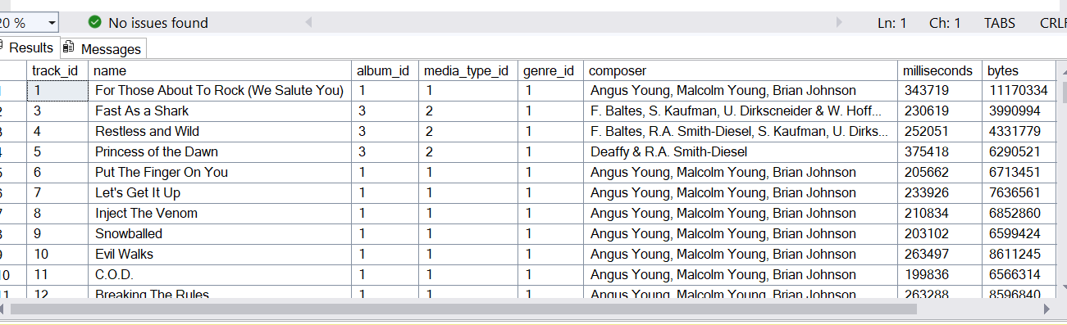
SELECT* FROM playlist_track
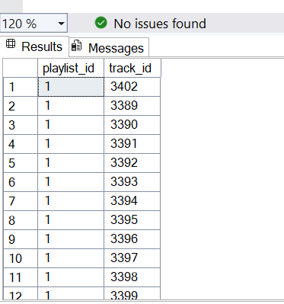
SELECT * FROM playlist
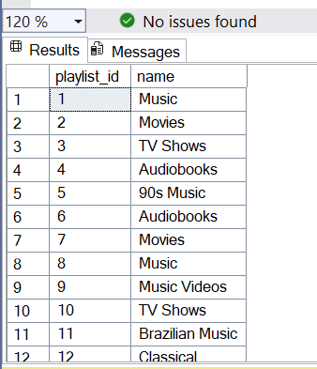
SELECT * FROM media_type
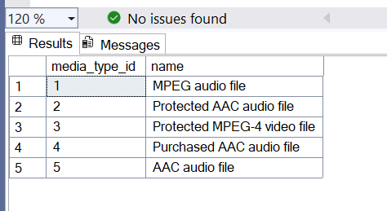
SELECT * FROM invoice_line
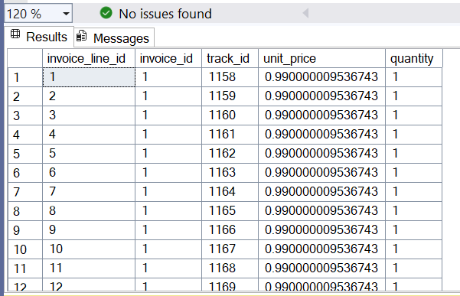
SELECT * FROM genre
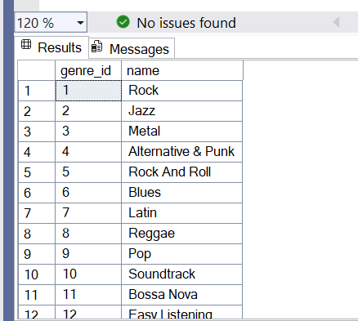
SELECT * FROM employee
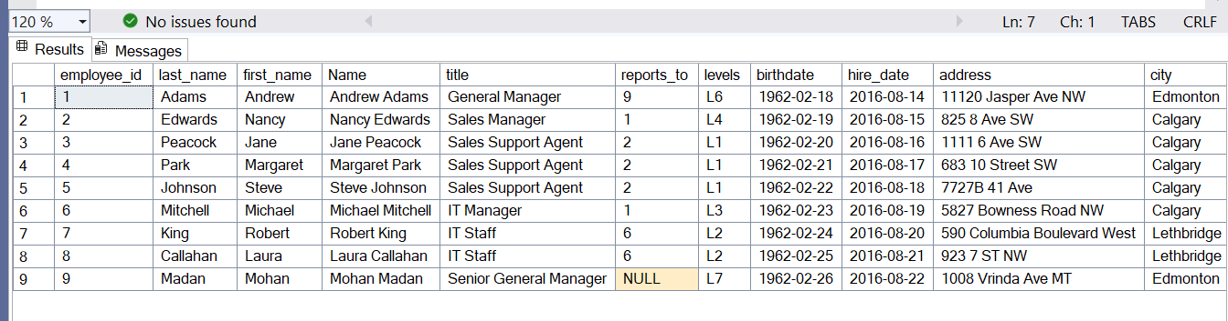
SELECT * FROM customer
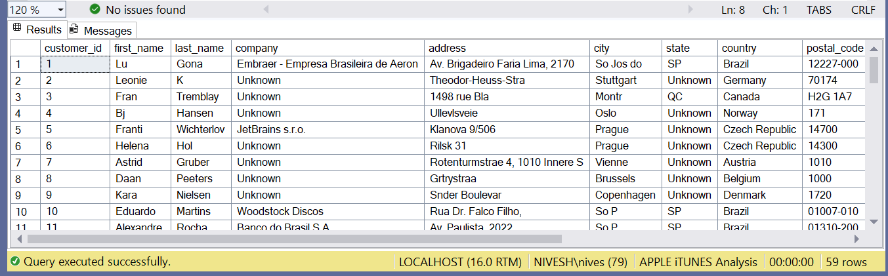
SELECT * FROM artist
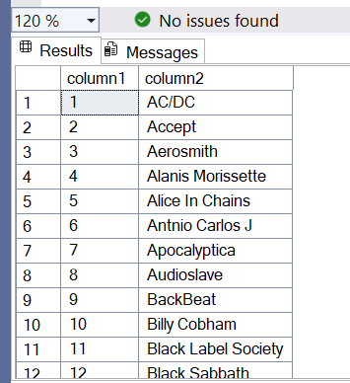
SELECT * FROM album
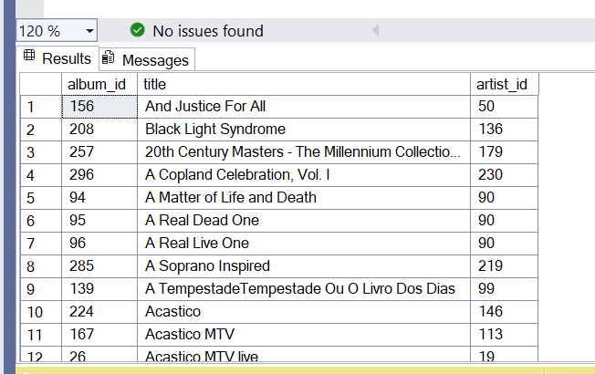
SELECT * FROM invoice
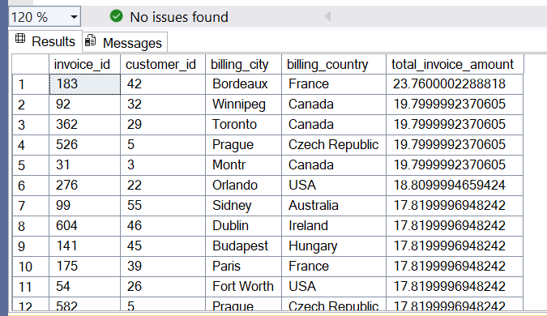

- Itunes Apple Music Store Analysis Q1-15
Q1. Who is the senior most employee based on job title?
SELECT employee_id,first_name,last_name
FROM employee
WHERE reports_to IS NULL;
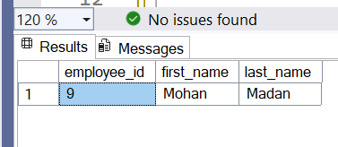
Q2. Which countries have the most Invoices?
SELECT billing_country,
COUNT(invoice_id)AS invoice_count
FROM invoice
GROUP BY billing_country
ORDER BY invoice_count DESC;
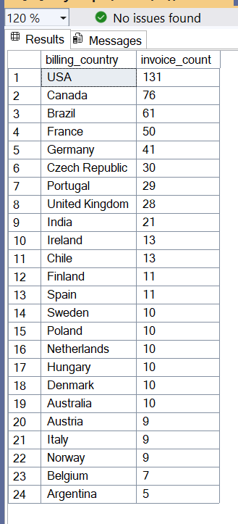
Top 10 countries have the most Invoices
SELECT top 10 billing_country,
COUNT(invoice_id)AS invoice_count
FROM invoice_copy
GROUP BY billing_country
ORDER BY invoice_count DESC;

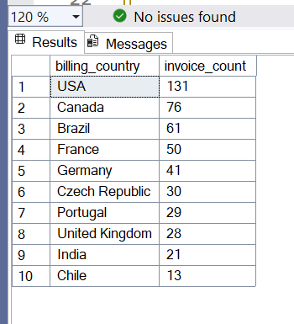

Q3. What are top 3 values of total invoice?

SELECT top 3 total_invoice_amount
FROM invoice
ORDER BY total_invoice_amount DESC;

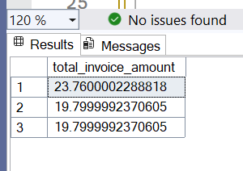
Rounding off the approximation

SELECT top 3 total_invoice_amount,
ROUND(total_invoice_amount,2) AS rounded_total
FROM invoice
ORDER BY total_invoice_amount DESC;

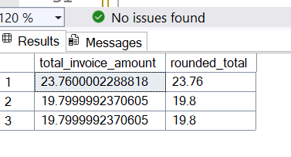

Q4. Which city has the best customers? We would like to throw a promotional Music Festival in the city we made the most money.
-- Write a query that returns one city that has the highest sum of invoice totals. Return both the city name & sum of all invoice totals.

SELECT top 1
billing_city,
SUM(total_invoice_amount) AS total_sales
FROM invoice
GROUP BY billing_city
ORDER BY total_sales DESC;

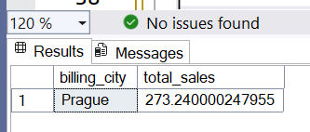

CustomerId of the customer spent the most money.
SELECT
customer_id,
SUM([total]) AS total_spent
FROM invoice_1
GROUP BY customer_id
ORDER BY total_spent DESC;
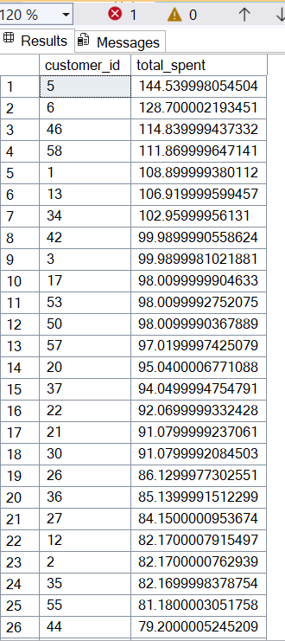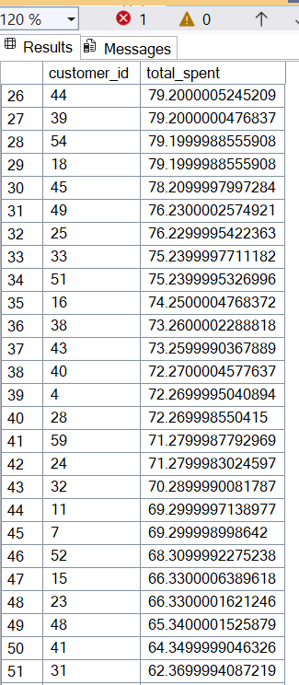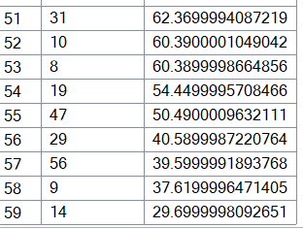

Q5. Who is the best customer? The customer who has spent the most money will be declared the best customer.

SELECT TOP 1
c.customer_id,
c.first_name,
c.last_name,
SUM(total_invoice_amount) AS total_spent
FROM customer AS c
INNER JOIN invoice AS i
ON c.customer_id = i.customer_id
GROUP BY c.customer_id, c.first_name, c.last_name
ORDER BY total_spent DESC;

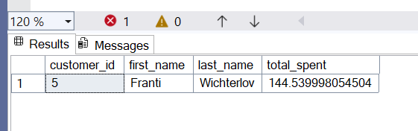

Q6. Write a query to return the email, first name, last name, & Genre of all Rock Music listeners. Return your list ordered alphabetically by email starting with A

SELECT DISTINCT
c.email,
c.first_name,
c.last_name,
g.name AS genre
FROM customer AS c
INNER JOIN invoice AS i
ON c.customer_id = i.customer_id
INNER JOIN invoice_line AS il
ON i.invoice_id = il.invoice_id
INNER JOIN track t
ON il.track_id = t.track_id
INNER JOIN genre g
ON t.genre_id = g.genre_id
WHERE g.name = 'Rock'
ORDER BY c.email ASC;

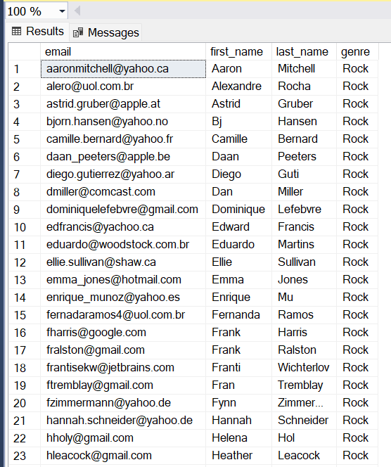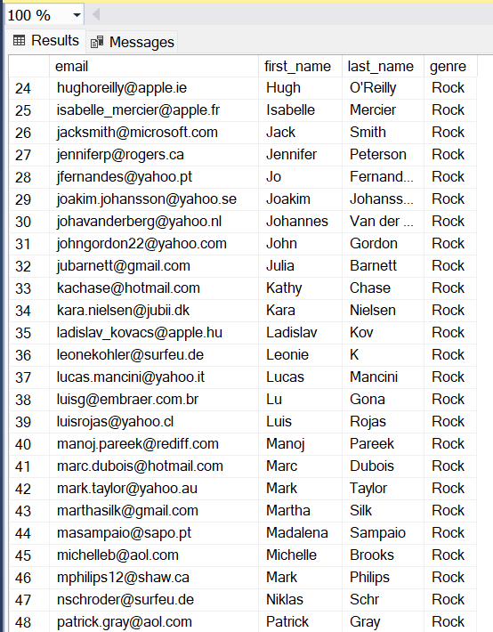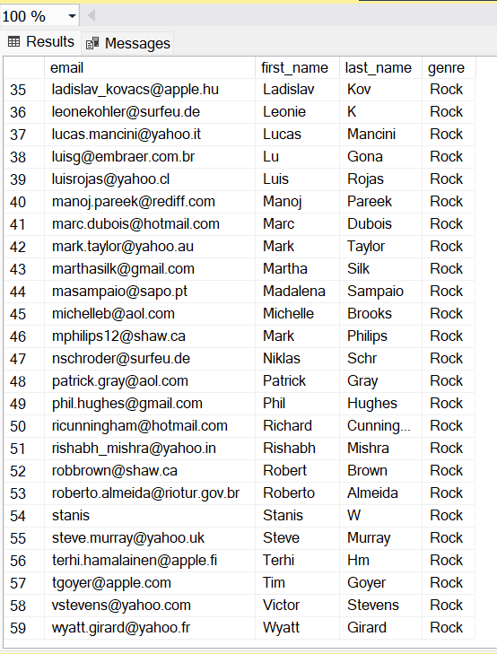

Q7. Let's invite the artists who have written the most rock music in our dataset.
-- Write a query that returns the Artist name and total track count of the top 10 rock bands.

SELECT
ar.name AS artist_name,
COUNT(t.track_id) AS rock_track_count
FROM track t
INNER JOIN album al
ON t.album_id = al.album_id
INNER JOIN artist ar
ON al.artist_id = ar.artist_id
WHERE t.genre_id = 1 -- Rock
GROUP BY ar.name
ORDER BY rock_track_count DESC
OFFSET 0 ROWS FETCH NEXT 10 ROWS ONLY;

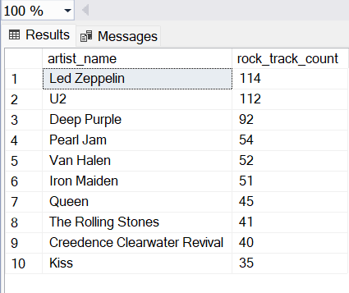

Q8. Return all the track names that have a song length longer than the average song length.
-- Return the Name and Milliseconds for each track. Order by the song length with the longest songs listed first.

SELECT AVG(milliseconds) FROM track

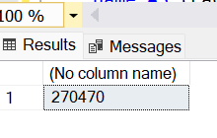

SELECT
name AS track_name,
milliseconds
FROM track
WHERE milliseconds > (
SELECT AVG(milliseconds) FROM track
)
ORDER BY milliseconds DESC;
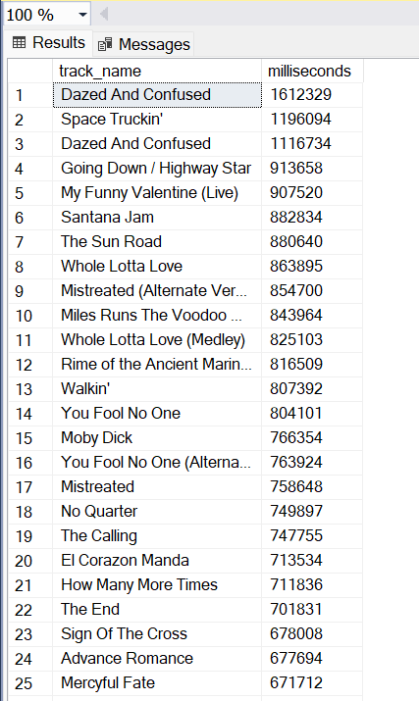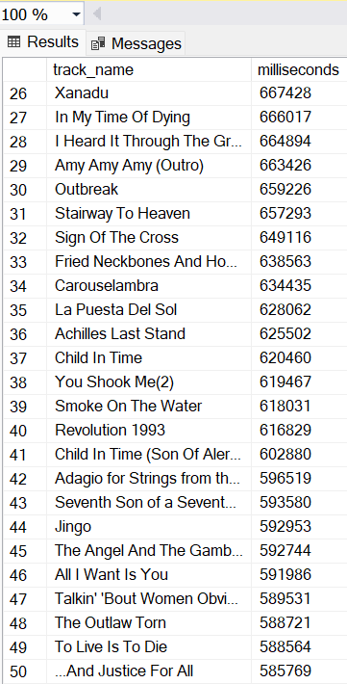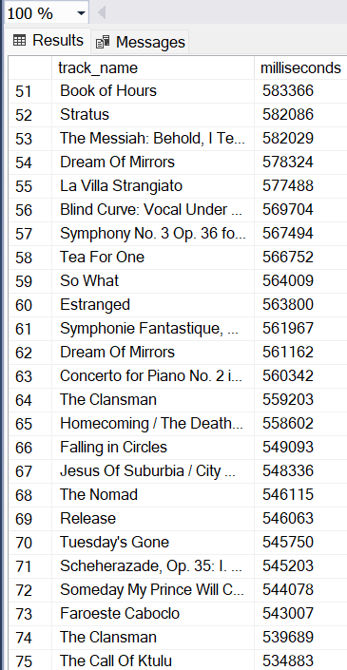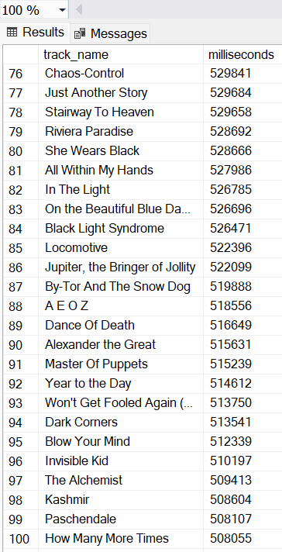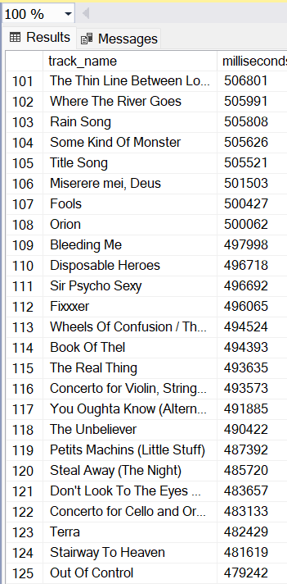
Q9. Find how much amount spent by each customer on artists. Write a query to return the customer name, artist name, and total spent.

SELECT
c.first_name,c.last_name AS customer_name,
ar.name AS artist_name,
SUM(il.unit_price * il.quantity) AS total_spent
FROM customer c
JOIN invoice i ON c.customer_id = i.customer_id
JOIN invoice_line il ON i.invoice_id = il.invoice_id
JOIN track t ON il.track_id = t.track_id
JOIN album al ON t.album_id = al.album_id
JOIN artist ar ON al.artist_id = ar.artist_id
GROUP BY c.first_name, c.last_name, ar.name
ORDER BY total_spent DESC;

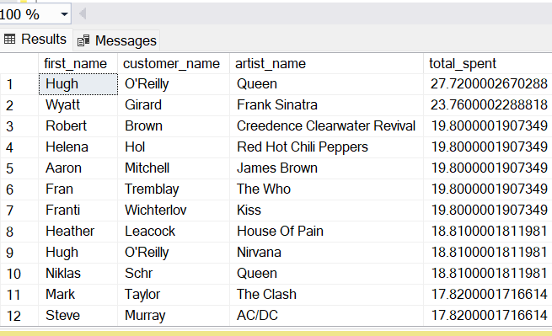

-- Q10. We want to find out the most popular music Genre for each country.
-- We determine the most popular genre as the genre with the highest amount of purchases.
-- Write a query that returns each country along with the top Genre. For countries where the maximum number of purchases is shared return all Genres.
WITH GenrePerCountry AS (
SELECT
c.country,
g.name AS genre_name,
COUNT(il.invoice_line_id) AS purchase_count
FROM customer c
JOIN invoice i
ON c.customer_id = i.customer_id
JOIN invoice_line il
ON i.invoice_id = il.invoice_id
JOIN track t
ON il.track_id = t.track_id
JOIN genre g
ON t.genre_id = g.genre_id
GROUP BY c.country, g.name
),
MaxGenre AS (
SELECT
country,
MAX(purchase_count) AS max_purchases
FROM GenrePerCountry
GROUP BY country
)
SELECT
gp.country,
gp.genre_name,
gp.purchase_count
FROM GenrePerCountry gp
JOIN MaxGenre mg
ON gp.country = mg.country
AND gp.purchase_count = mg.max_purchases
ORDER BY gp.country, gp.genre_name;

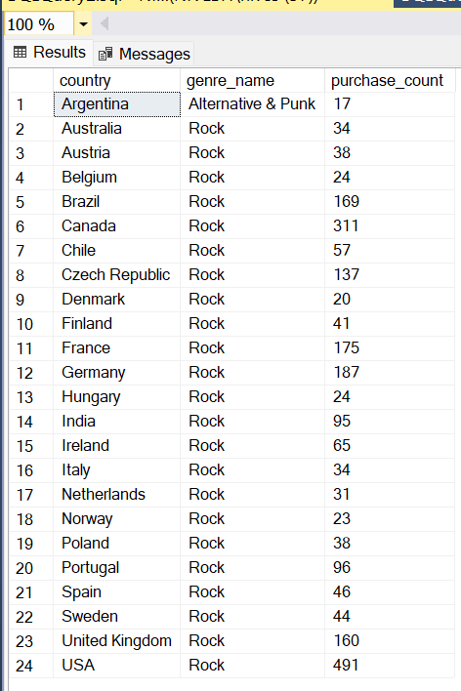

Q11. Write a query that determines the customer that has spent the most on music for each country. Write a query that returns the country along with the top customer and how much they spent. For countries where the top amount spent is shared, provide all customers who spent this amount.

WITH CustomerSpend AS (
SELECT
c.country,
c.customer_id,
c.first_name,
c.last_name,
SUM(i.total_invoice_amount) AS total_spent
FROM customer AS c
INNER JOIN invoice AS i
ON c.customer_id = i.customer_id
AND c.country = i.billing_country
GROUP BY c.country, c.customer_id, c.first_name, c.last_name
),
MaxSpend AS (
SELECT
country,
MAX(total_spent) AS max_spent
FROM CustomerSpend
GROUP BY country
)
SELECT
cs.country,
cs.customer_id,
cs.first_name,
cs.last_name,
cs.total_spent
FROM CustomerSpend cs
INNER JOIN MaxSpend ms
ON cs.country = ms.country
AND cs.total_spent = ms.max_spent
ORDER BY cs.country, cs.total_spent DESC;

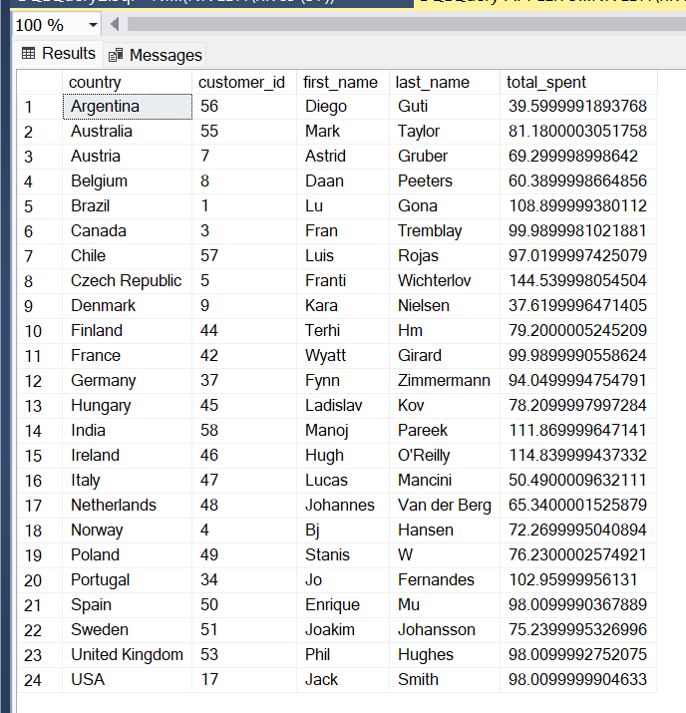

Q12. Who are the most popular artists?

SELECT TOP 10
ar.name AS artist_name,
SUM(il.quantity) AS total_purchases
FROM invoice_line il
JOIN track t
ON il.track_id = t.track_id
JOIN album al
ON t.album_id = al.album_id
JOIN artist ar
ON al.artist_id = ar.artist_id
GROUP BY ar.name
ORDER BY total_purchases DESC;

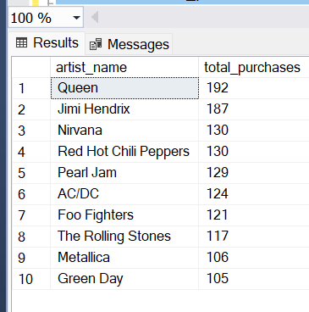

Q13. Which is the most popular song?
- On the basis of Purchase
SELECT TOP 1
t.name AS track_name,
SUM(il.quantity) AS total_purchases
FROM invoice_line il
JOIN track t
ON il.track_id = t.track_id
GROUP BY t.name
ORDER BY total_purchases DESC;

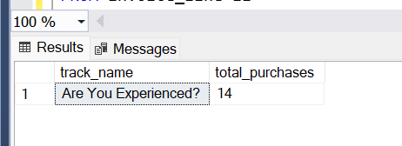
- On the basis of milliseconds spent

SELECT TOP 1
t.name AS track_name,
SUM(t.milliseconds * il.quantity) AS total_listen_time
FROM invoice_line il
JOIN track t
ON il.track_id = t.track_id
GROUP BY t.name
ORDER BY total_listen_time DESC;

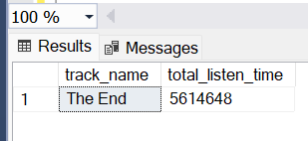

Q14. What are the average prices of different types of music?

SELECT
g.name AS genre_name,
ROUND(AVG(t.unit_price), 2) AS avg_price
FROM track t
JOIN genre g
ON t.genre_id = g.genre_id
GROUP BY g.name
ORDER BY avg_price DESC;

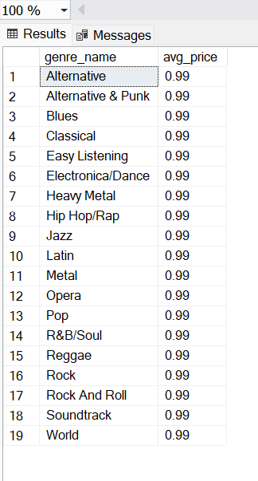

Q.15 What are the most popular countries for music purchases?
SELECT
billing_country,
COUNT(invoice_id) AS total_purchases
FROM invoice
GROUP BY billing_country
ORDER BY total_purchases DESC;

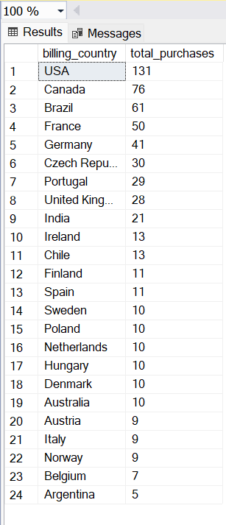

- Realistic Business Questions (DAX Calculations)

1. Customer Analytics
- Which customers have spent the most money on music?
- Which months or quarters have peak music sales?
- Which tracks generated the most revenue?

Customer Revenue =
SUMX(
RELATEDTABLE(invoice_line),
Invoice_line[unit_price] * invoice_line[quantity]
)
- What is the average customer lifetime value?
Total Customers = DISTINCTCOUNT(customer[customer_id])
Customer Lifetime Value =
DIVIDE([Total Revenue], [Total Customers])

- How many customers have made repeat purchases versus one-time purchases?
Repeat Customers =
CALCULATE(
DISTINCTCOUNT(invoice[customer_id]),
FILTER(
VALUES(invoice[customer_id]),
CALCULATE(COUNTROWS(invoice)) > 1
)
)
One-time Customers =
[Total Customers] - [Repeat Customers]

- Which country generates the most revenue per customer?
Revenue per Customer/average invoice value =
DIVIDE([Total Revenue], [Total Customers])

- Which customers haven't made a purchase in the last 6 months?
Inactive Customers =
CALCULATETABLE(
VALUES(customer[customer_id]),
NOT(
FILTER(
Invoice,
invoice[invoice_date] >= TODAY() - 180
)
)
)

2. Sales & Revenue Analysis
- What are the monthly revenue trends for the last two years?
Monthly Revenue = [Total Revenue]

- What is the average value of an invoice (purchase)?
Revenue per customer/Average Invoice Value = DIVIDE([Total Revenue], [Total Invoices])

- Which payment methods are used most frequently?
Payment Count =
COUNTROWS(Invoice)

- How much revenue does each sales representative contribute?
SalesRep Revenue =
SUMX(
RELATEDTABLE(invoice_line),
invoice_line[unit_price] * invoice_line[quantity]
)

3. Product & Content Analysis
- Which albums or playlists are most frequently included in purchases?
Album Purchase Count =
CALCULATE(
COUNTROWS(invoice_line),
ALLEXCEPT(Album, Album[Title])
)

